Nutrient Management
- pH and Conductivity

pH and Conductivity are the two most important variables in nutrient solution management. A basic understanding of them is essential for successful hydroponic gardening.
pH
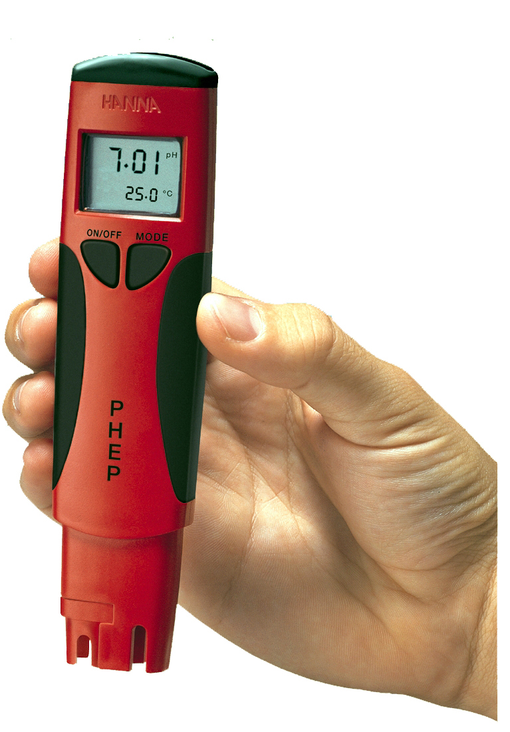
pH is a measurement of the acidity or alkalinity of a solution. On a scale of 1 - 14 neutrality is represented as 7. The ideal pH for almost all hydroponic applications is 5.5 - 6.

Measuring pH.
This can be done with a meter – such as the Hanna pHep or with a pH Test Kit
Correcting pH in hydroponic systems
In an active hydroponic system the pH will need checking and adjusting in the main tank on a regular (daily) basis.

Hard Water
Hard water will usually have a high pH but not necessarily. What will distinguish hard water is that it will take much more acid to reduce the pH than with an equivalent sample of softer water. This is because the Bicarbonates have to be neutralised and this uses up quite a lot of acid. The obvious problem for the grower is that he will be adding quite large amounts of acid on a regular basis. If he is using Phosphoric acid this may lead to a build up of Phosphate in the nutrient tank over time. High levels of P in the solution can inhibit the uptake of other salts, Zinc for instance, and cause general nutrient imbalance.

Nutrient Solutions for Hard Water.
If water is very Hard the grower may need to use a specific HW formulation. They are specifically designed to correct the pH of alkaline water and minimise the amounts of pH Down that are required to maintain it at correct levels. Use of these specific products will solve the problems of hard water and give great results for the grower.

Liquid Measurement.The best way to measure and transfer liquids is with a pipette or syringe. For larger amounts, graduated plastic jugs are ideal.

Conductivity
The conductivity of a solution is an expression of the capacity of that solution to conduct an electric current. The conductivity of a nutrient solution is therefore a measurement of its “strength” as indicated by the actual amount of salts dissolved. Conductivity is usually expressed in terms of EC. EC stands for Electrical Conductivity and the units of measurement are usually milliSiemens. Sometimes Conductivity is expressed as CF (Conductivity Factor) A CF unit is equal to a hundred microSiemens so there are 10 CF units to a milliSiemen.

Conductivity is measured by an EC meter such as Hanna Dist – or the amazing Bluelab Truncheon. With a meter like this a reading can be taken at regular intervals – if the EC has fallen then more stock solution can be simply added until the correct level is restored.

